PRESS RELEASE February 3, 2026, 7:00 am CEST

PUBLICATION OF A TRANSPARANCY NOTIFICATION

Brussels, Belgium – 3 February 2026 – Keyware (EURONEXT Brussels: KEYW) a leading supplier of electronic payment solutions and software development, discloses today that a shareholder has crossed below the 10% threshold.

According to Article 14, first paragraph, of the Law of 2 May 2007 on disclosure of major holdings in issuers whose shares are admitted to trading on a regulated Belgian market, Keyware Technologies NV (“Company”) discloses today that it has received a notification from Big Friend NV of an important participation triggered by a downward threshold crossing.

Summary
On 30 January 2026, Big Friend NV notified that it no longer holds voting rights in Keyware Technologies NV. The downward crossing of the 10% threshold is triggered by the sale of voting securities or voting rights.

Content
The received notification comprises the following information:

- The reason for the notification is triggered by the sale of voting securities or voting rights
- The notification is issued by the parent enterprise
- The legal entity subject to the notification requirement is Big Friend NV
- The transaction date is 26 January 2026
- The threshold that is crossed (downwards) is 10%
- The denominator is 22,516,649
- The notification details are as follows

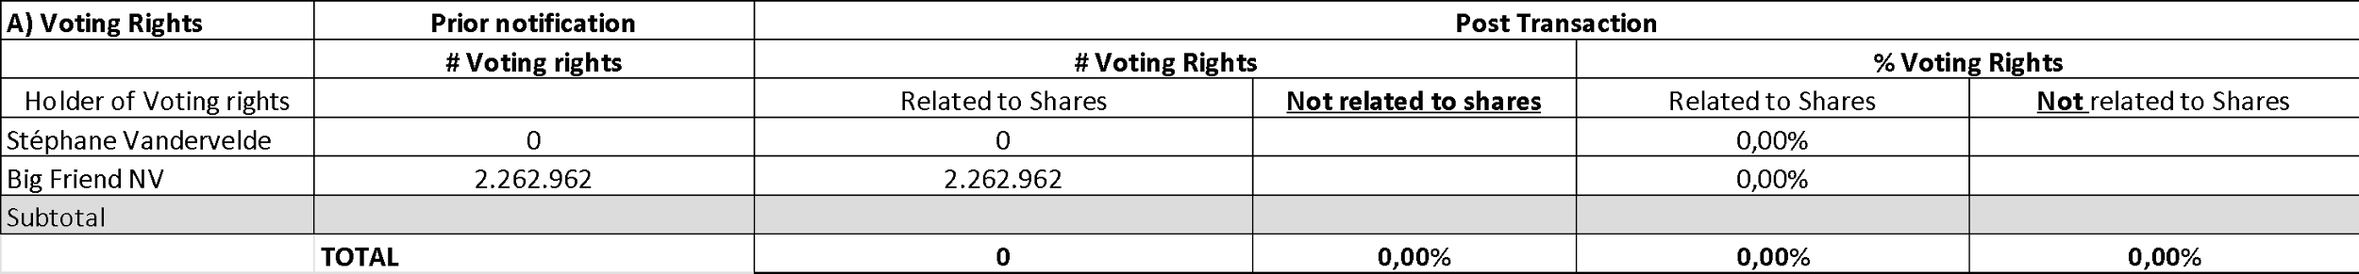

- Stéphane Vandervelde is the ultimate beneficial owner controlling Big Friend NV

The transparency notification can be consulted on the Company website in its original form (Dutch) via https://www.keyware.com/nl/investeerder/wettelijke-informatie/.

Statutory Thresholds
In accordance with the articles of association of Keyware Technologies NV and article 18 of the Law of 2 May 2007 on the disclosure of significant shareholdings, the threshold at which a shareholding must be disclosed is set at 5%, and thereafter at each multiple of 5%.

Notifications
Notifications must be submitted both to Keyware Technologies NV and to the FSMA. The FSMA requires electronic submission via the e-mail address trp.fin@fsma.be. Keyware also recommends sending a notification by e-mail marked for the attention of Keyware Investor Relations (ir@keyware.com). The relevant notifications are published on the investor page of Keyware under the section “Wettelijke informatie”.

About Keyware
Keyware (EURONEXT Brussels: KEYW) is a leading supplier of solutions for electronic payments and transactions processing, as well as a software developer for payment related solutions. Keyware is located in Zaventem, Belgium and more information is available at www.keyware.com.

For more information, please contact:

Mr. Pieter Geeraerts
CEO
Keyware Technologies NV
Phone: +32 (0)2 346.25.23
ir@keyware.com
www.keyware.com

